727721euit148

**CIA-1**

1)CODE:

package porm.demo.test;

import org.openqa.selenium.By;

import org.openqa.selenium.WebDriver;

import org.openqa.selenium.chrome.ChromeDriver;

import org.openqa.selenium.chrome.ChromeOptions;

import io.github.bonigarcia.wdm.WebDriverManager;

public class CIAQ1 {

public static void main( String[] args ) throws InterruptedException

{

ChromeOptions co = new ChromeOptions();

co.addArguments("--remote-allow-origins=*");

WebDriverManager.*chromedriver*().setup();

WebDriver driver = new ChromeDriver(co);

driver.get("https://www.amazon.in/ASUS-15-6-inch-GeForce-Windows-FA506IHRZ-HN111W/dp/B0B5DZTNZQ?ref_=Oct_DLandingS_D_6c1a28b8_61");

driver.manage().window().maximize();

String title = driver.getTitle();

String etitle = "ASUS TUF Gaming A15, 15.6-inch (39.62 cms) FHD 144Hz, AMD Ryzen 5 4600H, 4GB NVIDIA GeForce GTX 1650, Gaming Laptop (8GB/512GB SSD/Windows 11/Black/2.3 Kg), FA506IHRZ-HN111W : Amazon.in: Computers & Accessories";

System.***out***.println(title);

if(title.equals(etitle)) {

System.***out***.println("Title is matching");

}

else {

System.***out***.println("Title Mismatch");

}

driver.findElement(By.*xpath*("//*[@id=\"add-to-cart-button\"]")).click();

Thread.*sleep*(5000);

Boolean present = driver.findElement(By.*xpath*("//*[@id=\"attach-close_sideSheet-link\"]")).isDisplayed();

System.***out***.println("Is item added to cart:" + present);

driver.get("https://www.amazon.in/gp/cart/view.html/ref=dp_atch_dss_cart?");

Thread.*sleep*(5000);

driver.findElement(By.*xpath*("//*[@value=\"Delete\"]")).click();

Thread.*sleep*(2000);

String removeText = driver.findElement(By.*xpath*("//*[@id=\"sc-active-cart\"]/div/div[1]/div/h1")).getText();

String extext = "Your Amazon Cart is empty.";

if(removeText.equals(extext)) {

System.***out***.println("Product is removed");

}

driver.get("https://www.amazon.in/ASUS-15-6-inch-GeForce-Windows-FA506IHRZ-HN111W/dp/B0B5DZTNZQ?ref_=Oct_DLandingS_D_6c1a28b8_61");

driver.findElement(By.*xpath*("//*[@id=\"add-to-cart-button\"]")).click();

Thread.*sleep*(2000);

driver.get("https://www.amazon.in/gp/cart/view.html/ref=dp_atch_dss_cart?");

Thread.*sleep*(5000);

driver.findElement(By.*xpath*("//*[@id=\"a-autoid-0-announce\"]")).click();

driver.findElement(By.*xpath*("//*[@id=\"quantity_2\"]")).click();

Thread.*sleep*(2000);

driver.findElement(By.*xpath*("//*[@name=\"proceedToRetailCheckout\"] "));

Thread.*sleep*(1000);

String sign = driver.getTitle();

System.***out***.println(sign);

String esign = "Amazon Sign In";

if(sign.equals(esign)) {

System.***out***.println("Success");

}

else {

System.***out***.println("Failure");

}

}

}

**OUTPUT:**

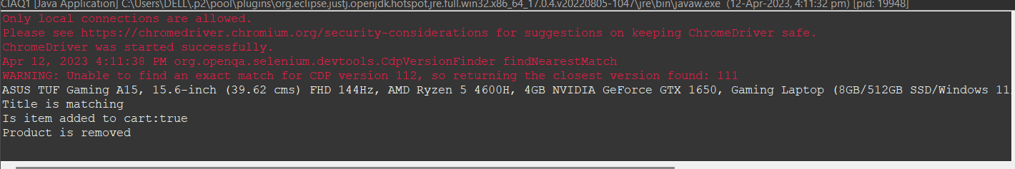

2)CODE:

package porm.demo.test;

import org.openqa.selenium.By;

import org.openqa.selenium.WebDriver;

import org.openqa.selenium.WebElement;

import org.openqa.selenium.chrome.ChromeDriver;

import org.openqa.selenium.chrome.ChromeOptions;

import io.github.bonigarcia.wdm.WebDriverManager;

public class CIAQ2 {

public static void main(String[] args) {

ChromeOptions co=new ChromeOptions();

co.addArguments ("--remote-allow-origins=*");

WebDriverManager.*chromedriver*().setup ();

WebDriver driver=new ChromeDriver(co);

driver.get ("https://www.amazon.in/");

driver.manage().window().maximize() ;

String currentTitle=driver.getTitle();

System.***out***.println(currentTitle);

String expectedTitle="Online Shopping site in India: Shop Online for Mobiles, Books, Watches, Shoes and More - Amazon.in";

if(currentTitle.equals(expectedTitle)) {

System.***out***.println("Title Matched");

}

else {

System.***out***.println("Title not Matched");

}

WebElement txtBoxl=driver.findElement(By.*xpath*("//*[@id=\"twotabsearchtextbox\"]"));

txtBoxl.sendKeys("Asus");

driver.findElement(By.*xpath*("//*[@id=\"nav-search-submit-button\"]")).click();

String txt1=driver.findElement(By.*xpath*("//*[@id=\"search\"]/div[1]/div[1]/div/span[1]/div[1]/div[3]/div/div/div/div/div/div/div/div[2]/div/div/div[1]/h2/a/span")).getText();

System.***out***.println(txt1);

String txt2=driver.findElement(By.*xpath*("//*[@id=\"search\"]/div[1]/div[1]/div/span[1]/div[1]/div[4]/div/div/div/div/div/div/div/div[2]/div/div/div[1]/h2/a/span")).getText();

System.***out***.println(txt2);

String txt3=driver.findElement(By.*xpath*("//*[@id=\"search\"]/div[1]/div[1]/div/span[1]/div[1]/div[5]/div/div/div/div/div/div[2]/div/div/div[1]/h2/a/span")).getText();

System.***out***.println(txt3);

String txt4=driver.findElement(By.*xpath*("//*[@id=\"search\"]/div[1]/div[1]/div/span[1]/div[1]/div[6]/div/div/div/div/div/div[2]/div/div/div[1]/h2/a/span")).getText();

System.***out***.println(txt4);

String txt5=driver.findElement(By.*xpath*("//*[@id=\"search\"]/div[1]/div[1]/div/span[1]/div[1]/div[7]/div/div/div/div/div/div[2]/div/div/div[1]/h2/a/span")).getText();

System.***out***.println(txt5);

driver.findElement(By.*xpath*("//*[@id=\"p_36/7252032031\"]/span/a/span")).click();

System.***out***.println("Over 50,000Rs");

driver.findElement(By.*xpath*("//*[@id=\"p_n_pattern_browse-bin/1464446031\"]/span/a/span")).click();

System.***out***.println("500-900GB");

}

}

**OUTPUT:**

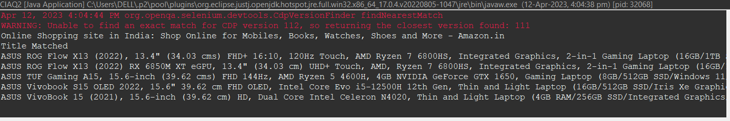

3)CODE:

package porm.demo.test;

import org.openqa.selenium.By;

import org.openqa.selenium.WebDriver;

import org.openqa.selenium.WebElement;

import org.openqa.selenium.chrome.ChromeDriver;

import org.openqa.selenium.chrome.ChromeOptions;

import io.github.bonigarcia.wdm.WebDriverManager;

public class CIAQ3 {

public static void main(String[] args) {

ChromeOptions co=new ChromeOptions();

co.addArguments ("--remote-allow-origins=*");

WebDriverManager.*chromedriver*().setup ();

WebDriver driver=new ChromeDriver(co);

driver.get ("https://www.amazon.in/");

driver.manage().window().maximize() ;

String currentTitle=driver.getTitle();

System.***out***.println(currentTitle);

String expectedTitle="Online Shopping site in India: Shop Online for Mobiles, Books, Watches, Shoes and More - Amazon.in";

if(currentTitle.equals(expectedTitle)) {

System.***out***.println("Title Matched");

}

else {

System.***out***.println("Title not Matched");

}

driver.findElement(By.*xpath*("//*[@id=\"nav-link-accountList\"]")).click();

WebElement txtBoxl=driver.findElement(By.*xpath*("//*[@id=\"ap_email\"]"));

txtBoxl.sendKeys("8220084761");

driver.findElement(By.*xpath*("//*[@id=\"continue\"]")).click();

WebElement txtBox2=driver.findElement(By.*xpath*("//*[@id=\"ap_password\"]"));

txtBox2.sendKeys("shriram0813sg");

driver.findElement(By.*xpath*("//*[@id=\"signInSubmit\"]")).click();

driver.findElement(By.*xpath*("//*[@id=\"nav-link-accountList\"]")).click();

driver.findElement(By.*xpath*("//*[@id=\"a-page\"]/div[2]/div/div[2]/div[1]/a/div/div")).click();

driver.findElement(By.*xpath*("//*[@id=\"a-autoid-2-announce\"]")).click();

driver.findElement(By.*xpath*("//*[@id=\"ordersInPackage-container\"]/div/div/a[1]")).click();

}

}